A data mining approach to discover unusual folding regions in genome sequences
Shu-Yun Le, Wei-min Liu, and Jacob V.Maizel Jr.
Knowledge-Based System, No.15, pp243-250, 2002
- Introduction
Numerous experiment and analysis of RNA structure have revealed that the local distinct structure closely correlates with the biological function. In this study,we present a data mining approach to discover such unusual folding regions(UFRs) in genome sequences.
- Mathematical Background

- UFR in an RNA sequence are assessed by the two scores , significant score(SIGSCR) , and stability score(STBSCR).

SIGSCR=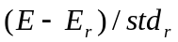

STBSCR=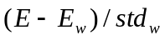

- Lineary transformed non-central Student`s t distribution(LTNSTD)

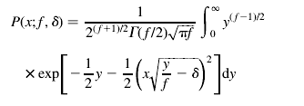 (1)
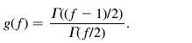 (2)

Let the data, SIGSCR & STBSCR be 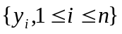

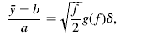 (3)
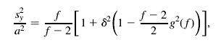 (4)
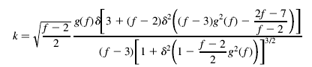 (5)
- Procedure

- first step : computing SIGSCR & STBSCR

- second step : deriving a LTNSTD for SIGSCR & STBSCR

- third srep : discoveries of UFRs

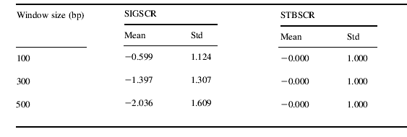

4.Result

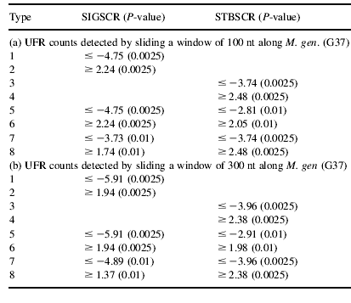

Created by : Hung-Wei Huang
Date : Oct. 25, 2002

